Steps to be taken in order to activate the cell in passivation,
- Build a circuit shown as below and mount the cells to be activated carefully
- Make sure switch K is at open position to adjust the variable resistance according to the chart @ http://electrochempower.com/Support/TechnicalInformation/passivation.htm
- Switch on the circuit and wait for a few seconds to up to 10 minutes as some old cells have very thick passivation layers built up.
- Switch off the circuit and measure the voltage provided by the cell
- Repeat the steps 2-4 until the cell voltage recovers to a normal level (> 3.0 volts).

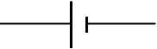

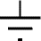
C
D

K

A
B

